Stealth Game Gameplay Summary

- The were cleaner
Free, simple to operate, and small in scale. The chase sequence only appears in the final level, making it perfect for beginners.
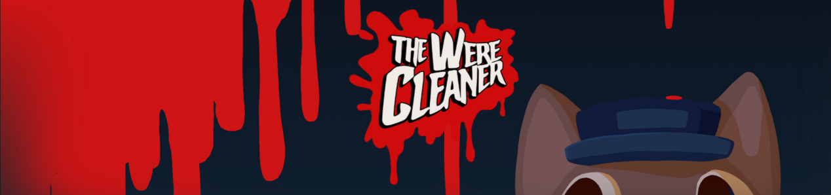
- Serial cleaners
A top-down third-person game released in recent years that isn't very well-known. It features diverse levels, so its level terrain design is worth referencing. It's a solid but unspectacular stealth game.
- Invisible inc
A niche game developed by Klei Entertainment, the studio behind Don't Starve. Surprisingly fun, though it lacks some balance—you might get stuck in the late game if you don't obtain god-tier items early on. However, it offers a wide selection of playable characters, and all levels are randomly generated (roguelike). You can choose different skills and items, and the gameplay is turn-based. I consider it an extremely worthwhile stealth game to reference. The core gameplay involves using randomly generated terrain cover to avoid enemies' line of sight. There are enemies with fixed patrol routes and pursuit routes, as well as a sound-based alert system. You can throw items to create diversions and lure enemies away. Playing it late game gives a strategic, chess-like sense of careful planning. It almost covers all the mechanics of top-down stealth games. Highly recommended!

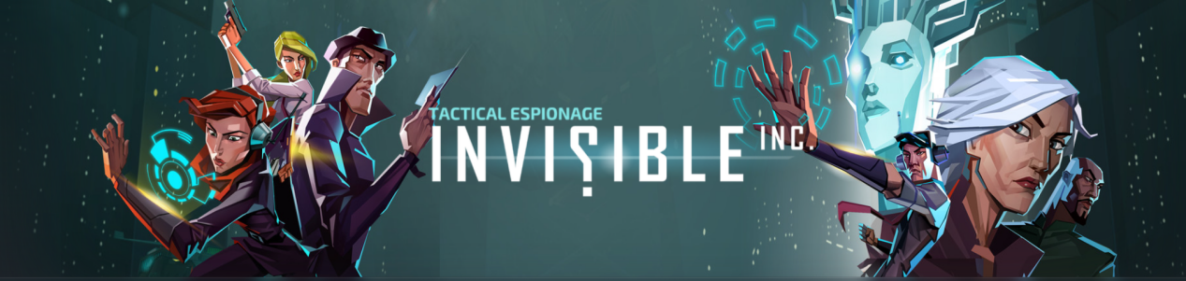
- Mark of the ninja remastered
Another niche game developed by Klei Entertainment (the studio behind Don't Starve). It's a pure 2D game, and its skills and map design are worth referencing. It's a solid but unspectacular stealth game.
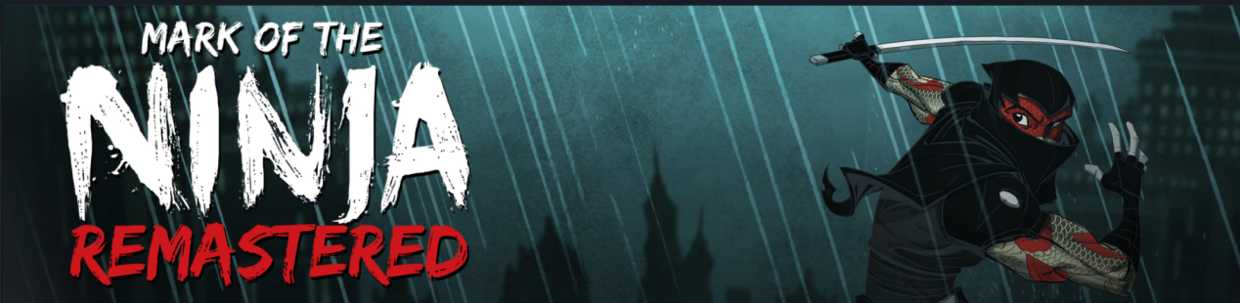

- Thief series
Look for the developer Eidos-Montreal. This is the iconic godfather of 3D stealth games. The first three Thief games are not recommended as they are too old, released 20 years ago. Instead, opt for Thief IV (2014), which plays without any major hurdles. It features a semi-open world with an extremely high degree of freedom, offering multiple ways to infiltrate each location. The hub world design of the main map is almost like a real-world setting, making it ideal for referencing map design and interaction mechanics: you can carefully sneak past enemies, use items to smash environmental light sources like oil lamps to create more dark areas for infiltration, or directly take down enemies. Highly recommended!
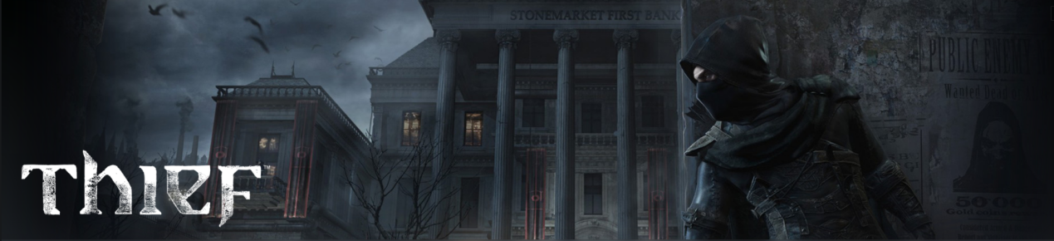
- Dishonored series
It shares most of the strengths of the Thief series and adds superpower mechanics to Thief's comprehensive stealth logic, resulting in more diverse gameplay. Its level design is a milestone in gaming history: first, you can freely traverse time and space within the same building—actions taken on NPCs and terrain in the past immediately affect the future map and storyline, allowing you to access previously unreachable areas or alter the plot direction. Second, the entire structure of the building features a mechanized mansion with changeable layouts. Despite being complex and intricate, the map guidance is excellent, and you'll definitely be amazed no matter how many times you play it. Highly recommended!
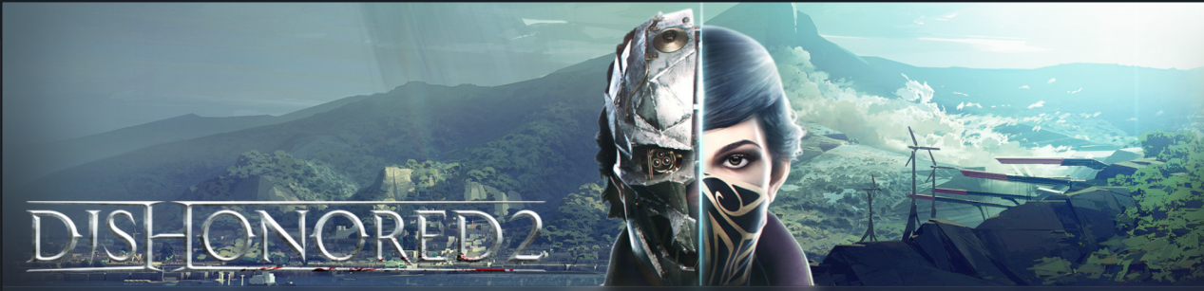
- assassin’s creed series
It's so famous that there's not much to say. There are numerous entries in the series, with some focusing on berserker-style hack-and-slash combat and others on stealth—you'll need to check which specific installment suits your preference. However, it suffers from the common flaw of cookie-cutter games, where the gameplay becomes largely similar in the late stages. It's advisable to do your research in advance and carefully select the one that interests you the most (generally, later releases have more content but less stealth-focused gameplay).
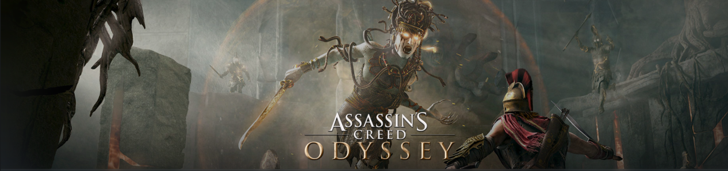
- Thief and crime simulator series
New stealth games released in recent years. They offer almost no means to counter NPCs, so the gameplay is thrilling without being terrifying. You can only hide or flee based on NPCs' movement routes, taking hide-and-seek to the extreme. Other aspects are solid but unspectacular, with no rich gameplay or skills. They're playable when you're short on games.
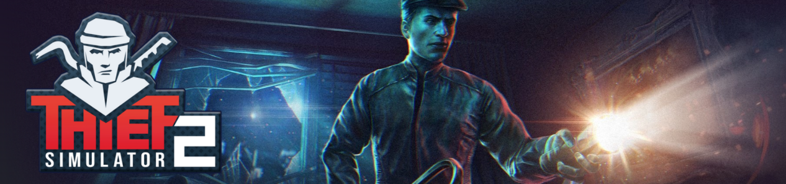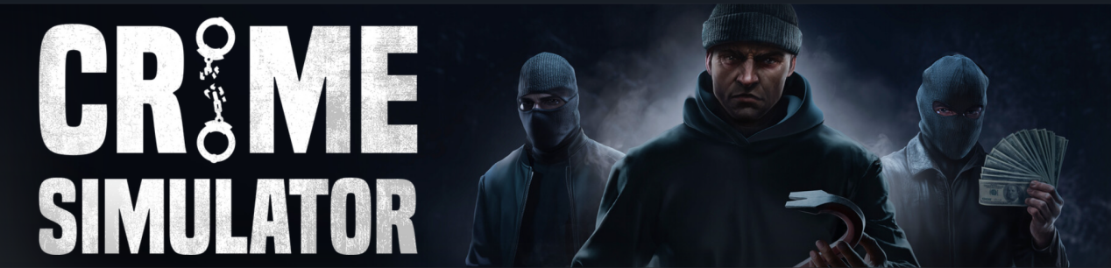
- Watch dogs 2
An open-world game developed by Ubisoft (the studio behind Assassin’s Creed). Its core gameplay is stealth, but it’s set in a hacker-themed world. Unlike previous stealth games where you carefully navigate through maps to avoid enemies, this one relies more on hacking skills to remotely control dangerous environmental objects to explode and eliminate NPCs, or hack into enemy network systems to disable cameras, etc. It’s fun but also a bit of a cookie-cutter game. Its hacker-style remote interaction mechanics with NPCs are worth referencing.

- Kingdom Come: Deliverance series
A highly popular medieval open-world hardcore simulator released last year. It offers an extremely realistic and immersive large world, where the protagonist must perform all actions strictly step-by-step just like people in the real Middle Ages. For example, making herbal medicine requires picking herbs, grinding, mixing, distilling, bottling, and other steps. It includes some stealth gameplay, though it doesn’t take up much of the overall experience—but you can also rely solely on stealth (theft) to obtain resources throughout the game, offering a high degree of freedom. The game is extremely large in scale, so it’s recommended to fully understand if you’re the target audience before purchasing; it might frustrate impatient players.

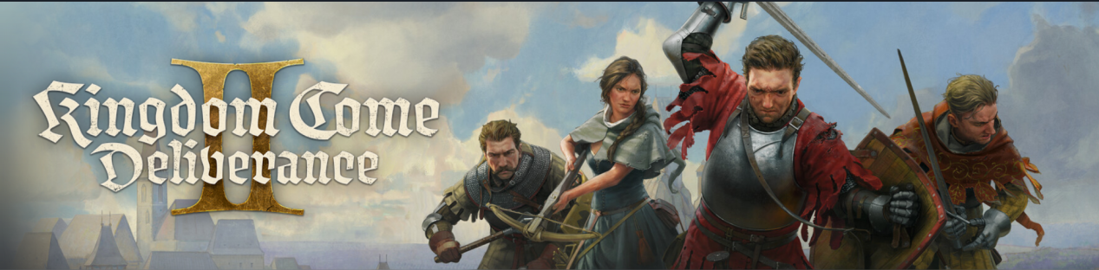
- Payday 2
I bought it but haven’t played much (it requires online co-op). It supports both stealth and brute-force approaches. Compared to evasion, it feels more focused on teamwork and shooting mechanics.

- Limbo/Inside
Small-scale 2.5D side-scrolling action-puzzle games. Each takes about 5 hours to complete, with some stealth elements, but the core gameplay is still puzzle-solving.

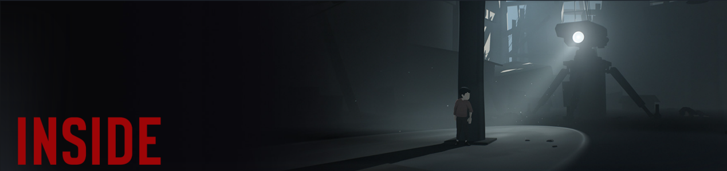

The following are well-known stealth games I haven’t played but will briefly introduce based on my knowledge for your reference:
- Hitman series
It has numerous versions and DLCs, making it quite complex and confusing, but it’s a qualified and famous stealth assassination game.

- Metal Gear series
A classic, but it never goes on sale on Steam and is mainly sold on the PS4 console. Physical copies are hard to come by.
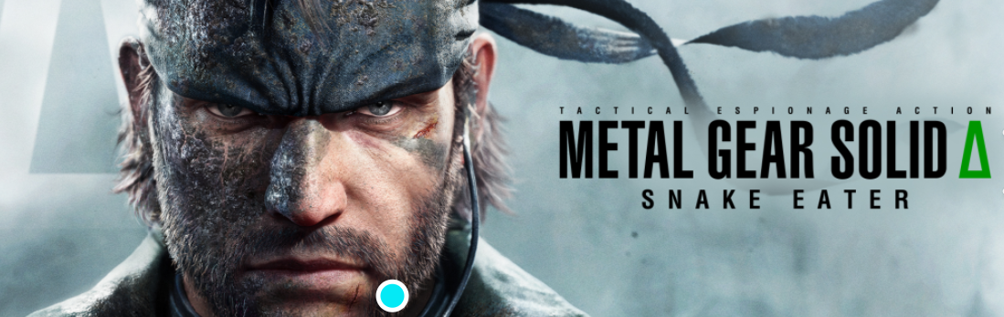
- Shadow Tactics series
I can’t remember why I didn’t buy it, but it’s a classic top-down stealth strategy game that looks very fun. I plan to purchase it.
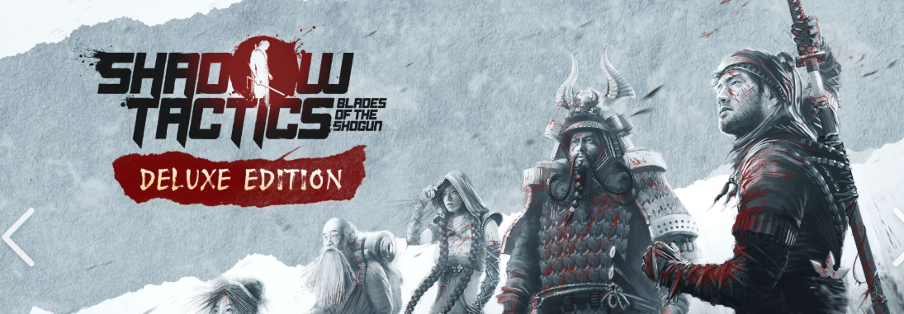
- Desoerados series
It looks very similar to Shadow Tactics and has been added to my wishlist.
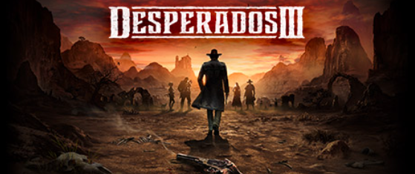
- Intravenous series
A niche, small-scale pixel-style 3D-to-2D top-down game with average reviews. It’s playable when you’re short on games.
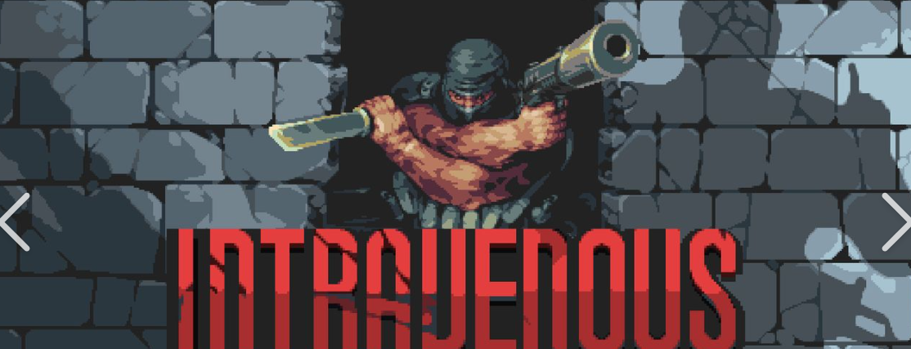
- A Plague Tale series
A relatively famous disaster-themed game. It feels a bit scary to me, so I didn’t buy it, but you can give it a try.

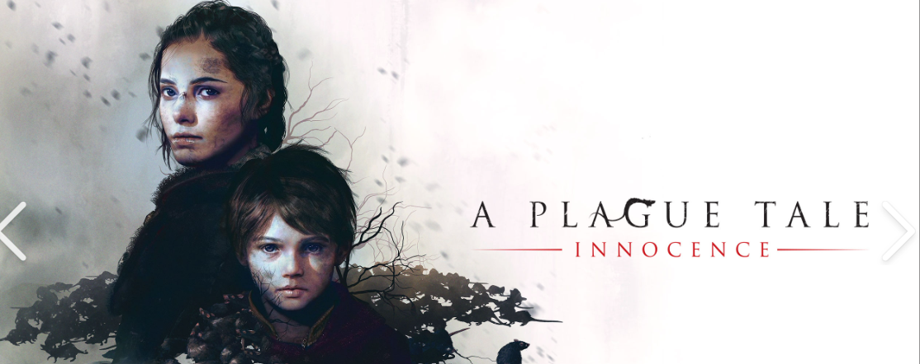
- Deus Ex series
A well-known stealth shooter RPG with a lot of FPS content. It’s worth trying.
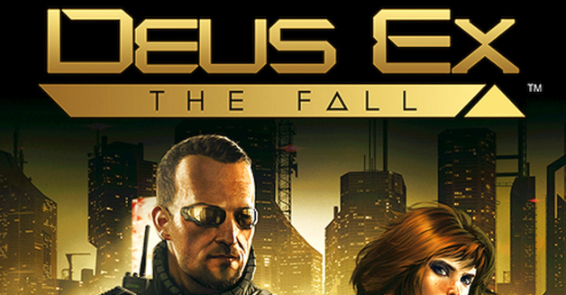
- DEATHLOOP
A new game from the developer of the Dishonored series. It has won numerous awards and received critical acclaim. Its multiple playthroughs with interrelated time loops inherit the excellent level design of the Dishonored series. Although it has a lot of FPS content, it’s definitely worth playing.
